About us:

Visalakshi Industries Started In 2021.

## Technology Promoters

Visalakshi Industries Is Supported By A Group Of Expert Committee For Continuous Research For Everlasting Growth In terms Of Technology, Quality, Safety & Cost Oriented.

## What We Can Deliver

Visalakshi Industries With Its Highly Experienced Personal Manufacture & Supply Sophisticated Equipment’s To Suit Utmost Safely Produce Constant Quality Product To Work With Zero Break Downs With Optimized Man-Power & Energy Items For All The Cement, Iron Ore/Sponge Iron Projects, Minig Industries, Coal Industries, Steel Bridges, Peb Buildings, Chemical, Pharmaceutical Food Processing Industries, Ports (Ship Yards), Airports And All Steel Structures Etc., We Are Also Pioneered In Sand Blasting, Copper Slag Blasting, Airless Painting And Metalizing.

Infrastructure:

* MANUFACTURING UNIT IN – 1 ACRE.
* OPEN AREA – 12000 SFT
* PLANT COVERED AREA – 24717 SFT
* AUXILARY COVERED AREA SHED 1 – 11556 SFT
* AUXILARY COVERED AREA SHED 2 – 11085 SFT
* OFFICE & STORES AREA – 2326 SFT
* 20 TON EOT Crane – 1 Nos.
* 7.5 TON EOT Crane – 1 Nos.
* 3 TON EOT Crane – 1 Nos.
* 14 TON HYDRA – 1 Nos.
* 12 TON HYDRA – 1Nos.
* CHAIN BLOCKS 1, 2, 3&5tons– 6 Nos.
* 125 KVA GENERATOR – 1 Nos.
* 60 HP COMPRESSOR – 1 Nos.
* SAW WELDING MACHINES – 2 Nos.
* MIG WELDING MACHINES – 10 Nos.
* ARC WELDING MACHINES – 15 Nos.
* TIG WELDING MACHINES – 2 Nos.
* ANGLE GRINDER 7″, 5” & 4” – 25 Nos.
* MOTHER OVEN – 1 Nos.
* PORTABLE OVEN – 6 Nos.
* PUG MACHINES – 6 Nos.
* BROCH CUTTING MACHINE 32& 50mm– 3 Nos.
* CHOPSAW CUTTER MACHINE – 4 Nos.
* SAND BLASTING COMPRESSOR – 3 Nos.
* SAND BLASTING HOPPERS – 6 Nos.
* AIRLESS PAINITNG PUMPS – 5 Nos.
* METELLIZING EQUIPMENT – 1 SET.

OUR PRODUCTS

Fabrication & Erection Product Range:

* All kind of structural Buildings
* Steel Bridges
* PEB Buildings
* Railway Bridges
* Railway Platform Sheds.
* Sand and Copper Slag Blasting.
* Airless Painting.
* Metallizing.

**DETAILS OF TESTING FACILITY**

* Dye-penetration Test Radiographic Test
* Radiographic Test (Through Outside Agency)
* Magnetic Particle Test
* Ultrasonic Test
* Hardness Test
* Hot & Cold Tensile Strength
* Bending Test
* Corrosion Test

QUALITY POLICY:

**VISALAKSHI INDUSTRIES IS DEDICATED TO:**

* QUALITY OF PRODUCT
* TIMELY DELIVERY
* PROMPT RESPONSE TO CUSTOMERS NEEDS
* PROMOTING GOOD RELATIONS WITH VENDORS
* PROVIDING GOOD ENVIRONMENT FOR OUR EMPLOYEES

**QUALITY POLICY**

**VISALAKSHI INDUSTRIES** is committed to enhance customer satisfaction by manufacturing and supplying process equipment’s and general engineering as per customer requirements and on time delivery by continually improving the effectiveness of quality management systems.

**CUSTOMER FOCUS:**

Top management ensures that customer needs and requirements are determined and convers them in to the form of defined requirements. Top management also ensures that the defined requirements are fully understood and met.

**QUALITY PROCEDURES:**

VISALAKSHI INDUSTRIES is committed to follow the procedures for our internal manufacturing process.

SAFETY POLICY

**It is the policy of VISALAKSHI INDUSTRIES to conduct its operations in such a way as to fully ensure the safety of its Employees and other persons working in its plants. We give high priority to this policy as safety and productivity go together.**

**VISALAKSHI INDUSTRIES** **follows the following steps to achieve safety:**



All the workmen in the shop floor must use safety shoes and safety helmets

All grinders, welders and gas cutters must wear eye glasses & Safety helmets.

Fire extinguishers are placed near main electric station and minimum of 6 other places in the plant.

All electrical installations are examined fortnightly.

Safety audit every 4 months.

Our projects

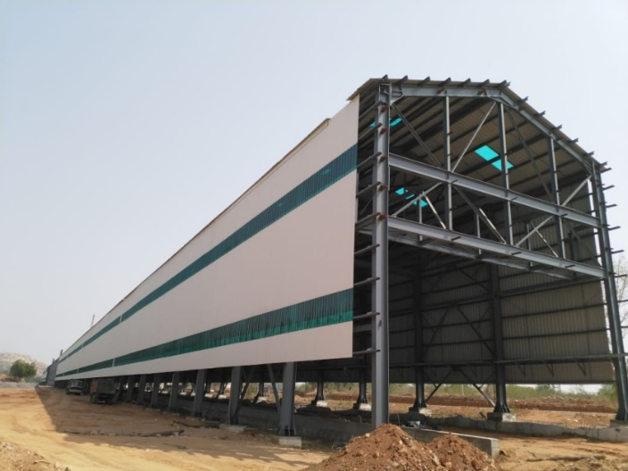

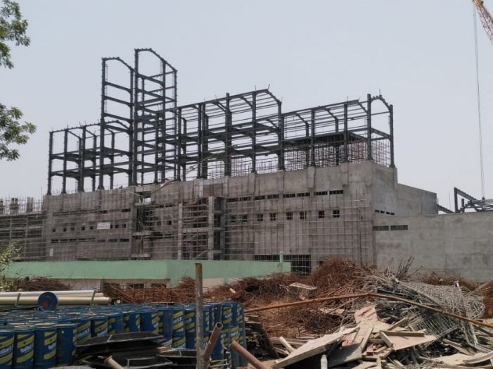

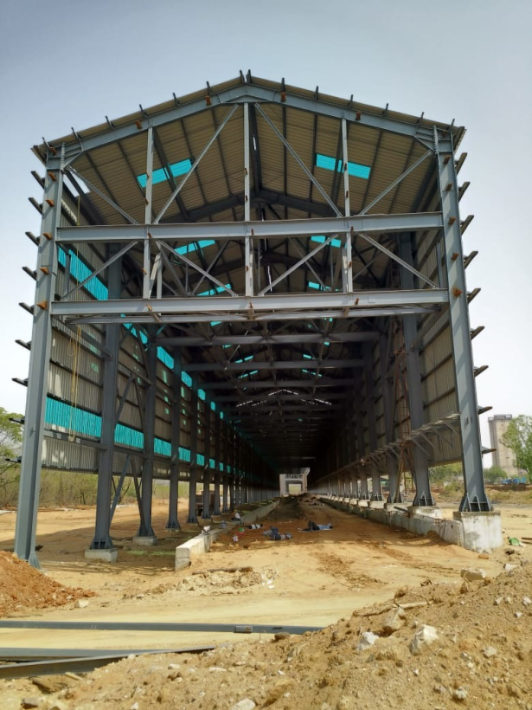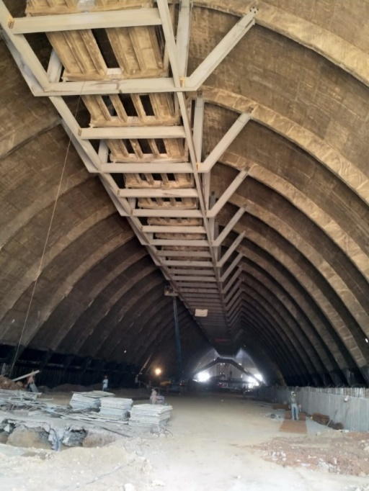

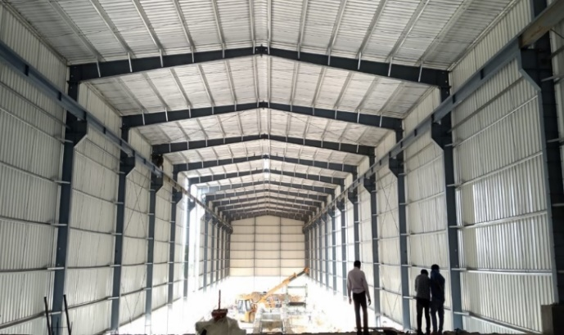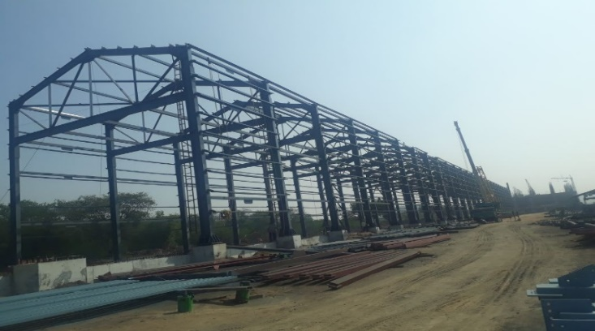

i

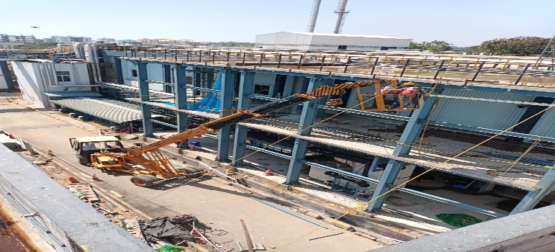

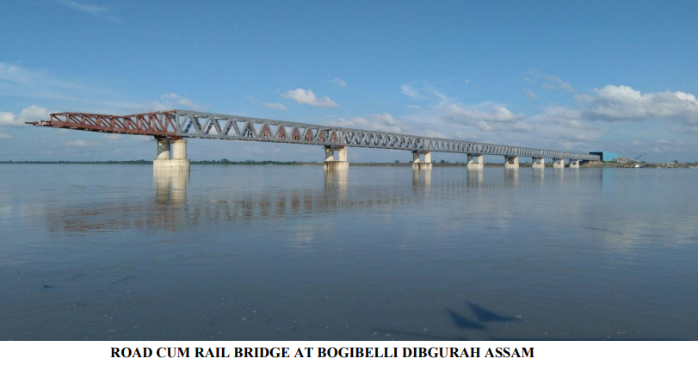

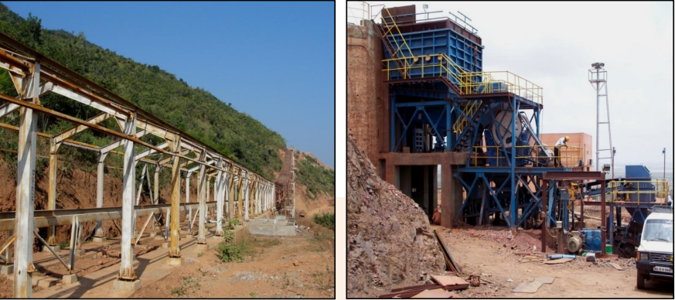

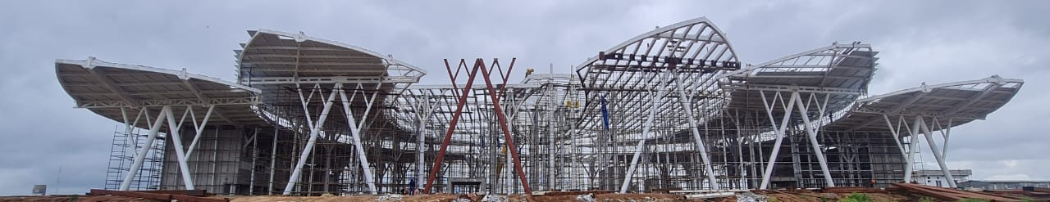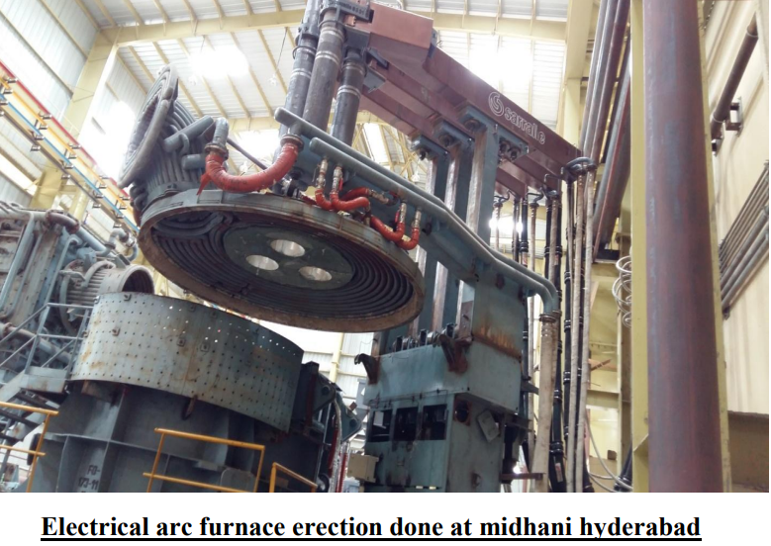

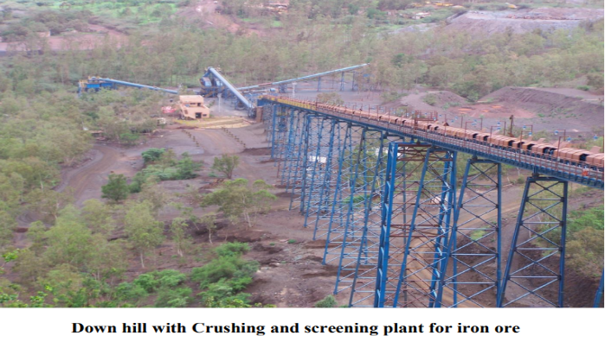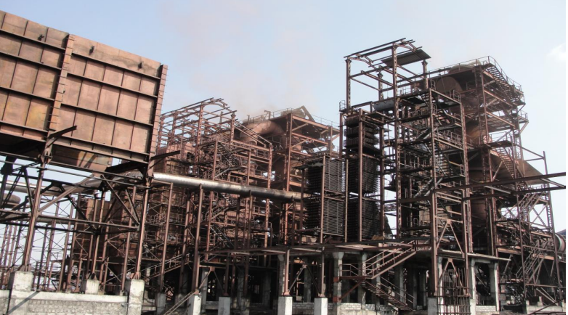

Clients:

* A one Steel & Alloyes Pvt.Ltd.
* APL Apollo Tubes Ltd.
* Ardee Engineering Private Limited.
* Bhaskar Resources Private Limited.
* GR Infracon Private Limited.
* Jeevika Netting Udyog.
* JK Fenner India Limited.
* Kirby Building Systems & Structures India Private Limited.
* KMV Projects Private Limited.
* Marutiispat & Energy Pvt.Ltd.
* M Venkatarao Infra Projects Pvt.Ltd.
* Navya Construction.
* NCL Buildtek Limited.
* Niehoff of India Pvt.Ltd.
* NJR Construction Private Limited.
* Pennar Industries Limited.
* Quant Solar Technologies Private Limited.
* Saivijaya Pragathi Steel Udyog Pvt.Ltd.
* Samaya Project Services Pvt.Ltd.
* Shiva Satya Engineering Servises Pvt.Ltd.
* SRC Company Infra Pvt.ltd.
* SRR Projects Private Limited.
* Srichakra Polyplast India Private Limited.
* Shapoorji Pallonji group
* Western Outdoor Structures Pvt.Ltd.
* Gr infra
* Insteel pvt ltd
* Vanya steels
* Sugoan sponge pvt ltd

**contact us**

VISALAKSHI INDUSTRIES

Sy.No. 180/7, Kaziaplly,

Jinnaram Mandal, Sangareddy District,

Near Hyderabad O.R.R Dundigal Exit. No 5,

Telangana-502319

Ph: +91 8121035599

E-mail: [visalakshi.ind@gmail.com](mailto:visalakshi.ind@gmail.com)

Our CLIENTS

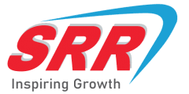

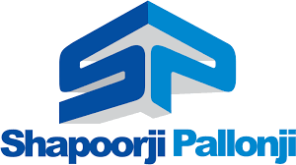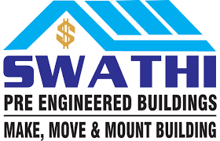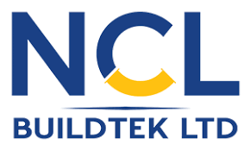



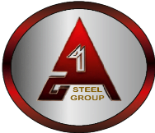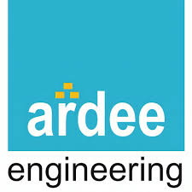

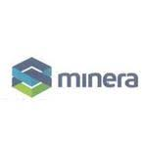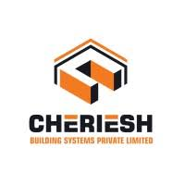

Our end-users

